**Goal: Create & connect to an EC2 instance and copy the file from local desktop to the server using SCP and now create a S3 bucket and copy the file from the server to the S3 bucket.**

Best practice is to login and do daily work as an IAM user - NOT as the root user.

After logging as an IAM User now create an IAM user and EC2 instance. For creating user click on Services ->Security, Identity & Compliance -> IAM-> Users -> Add Users

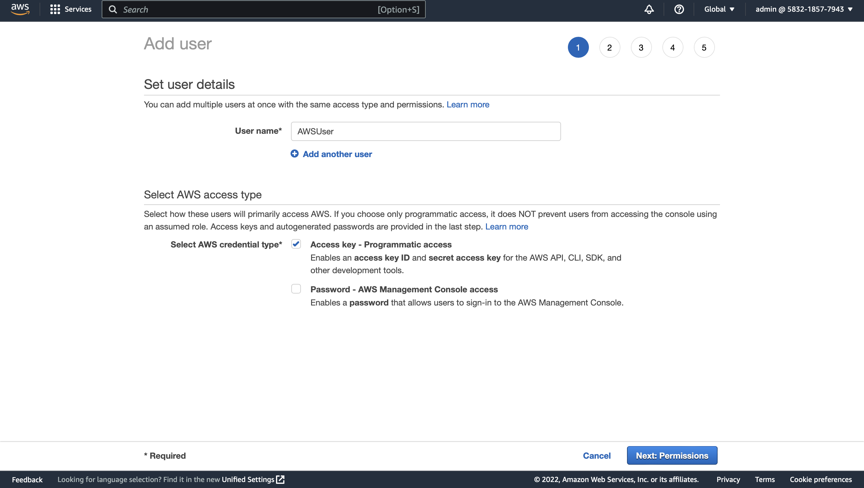

I have created a user called AWSUser with Programmatic Access and I haven't given any permissions to it just click next and review and make sure to download the .csv file.

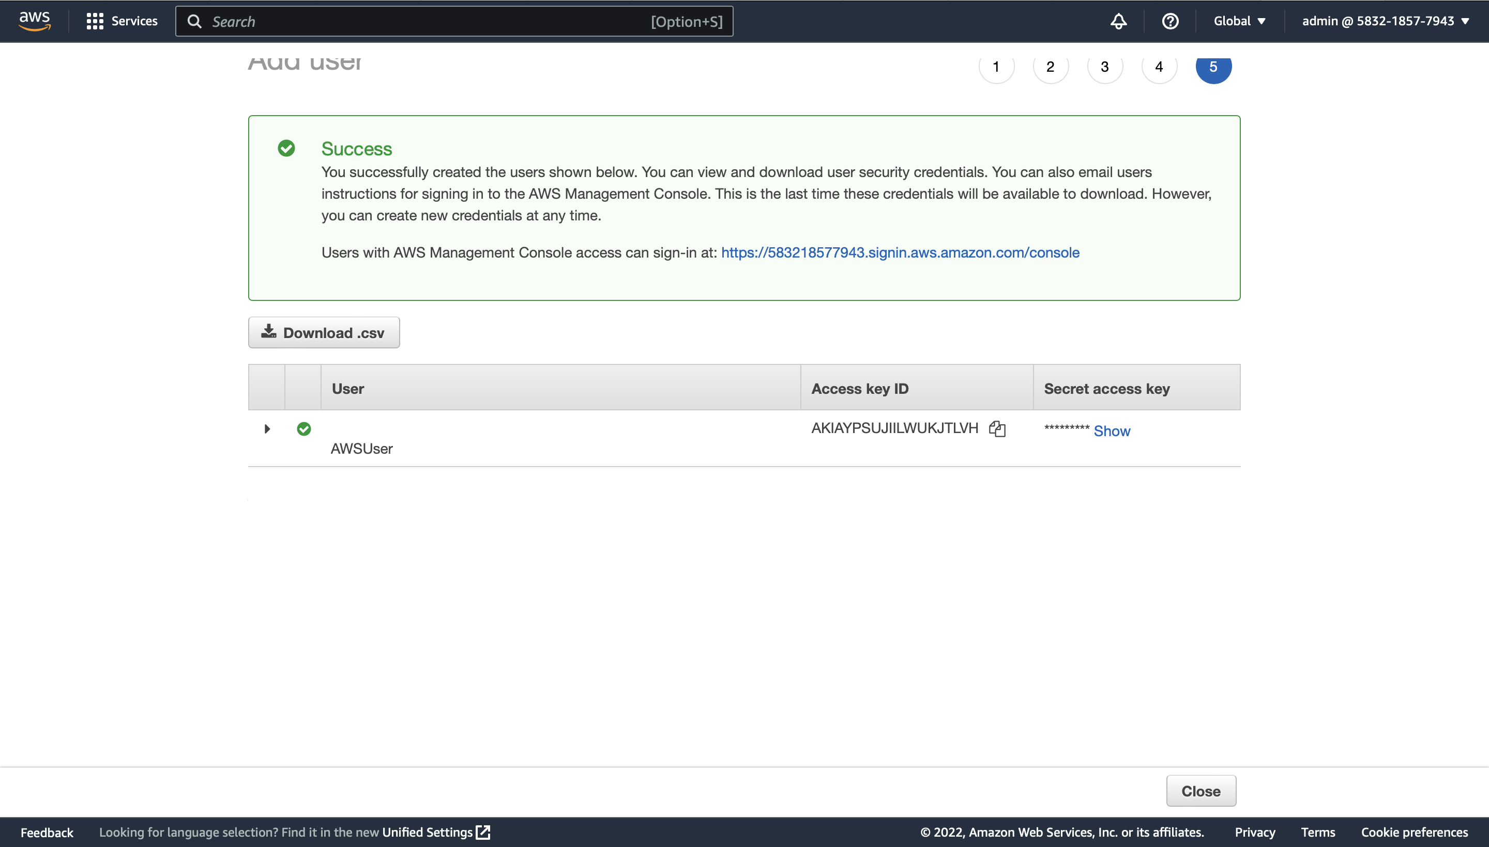

After creating a user here, I have created an instance called AWS server with all the default values like server type, firewall and storage.

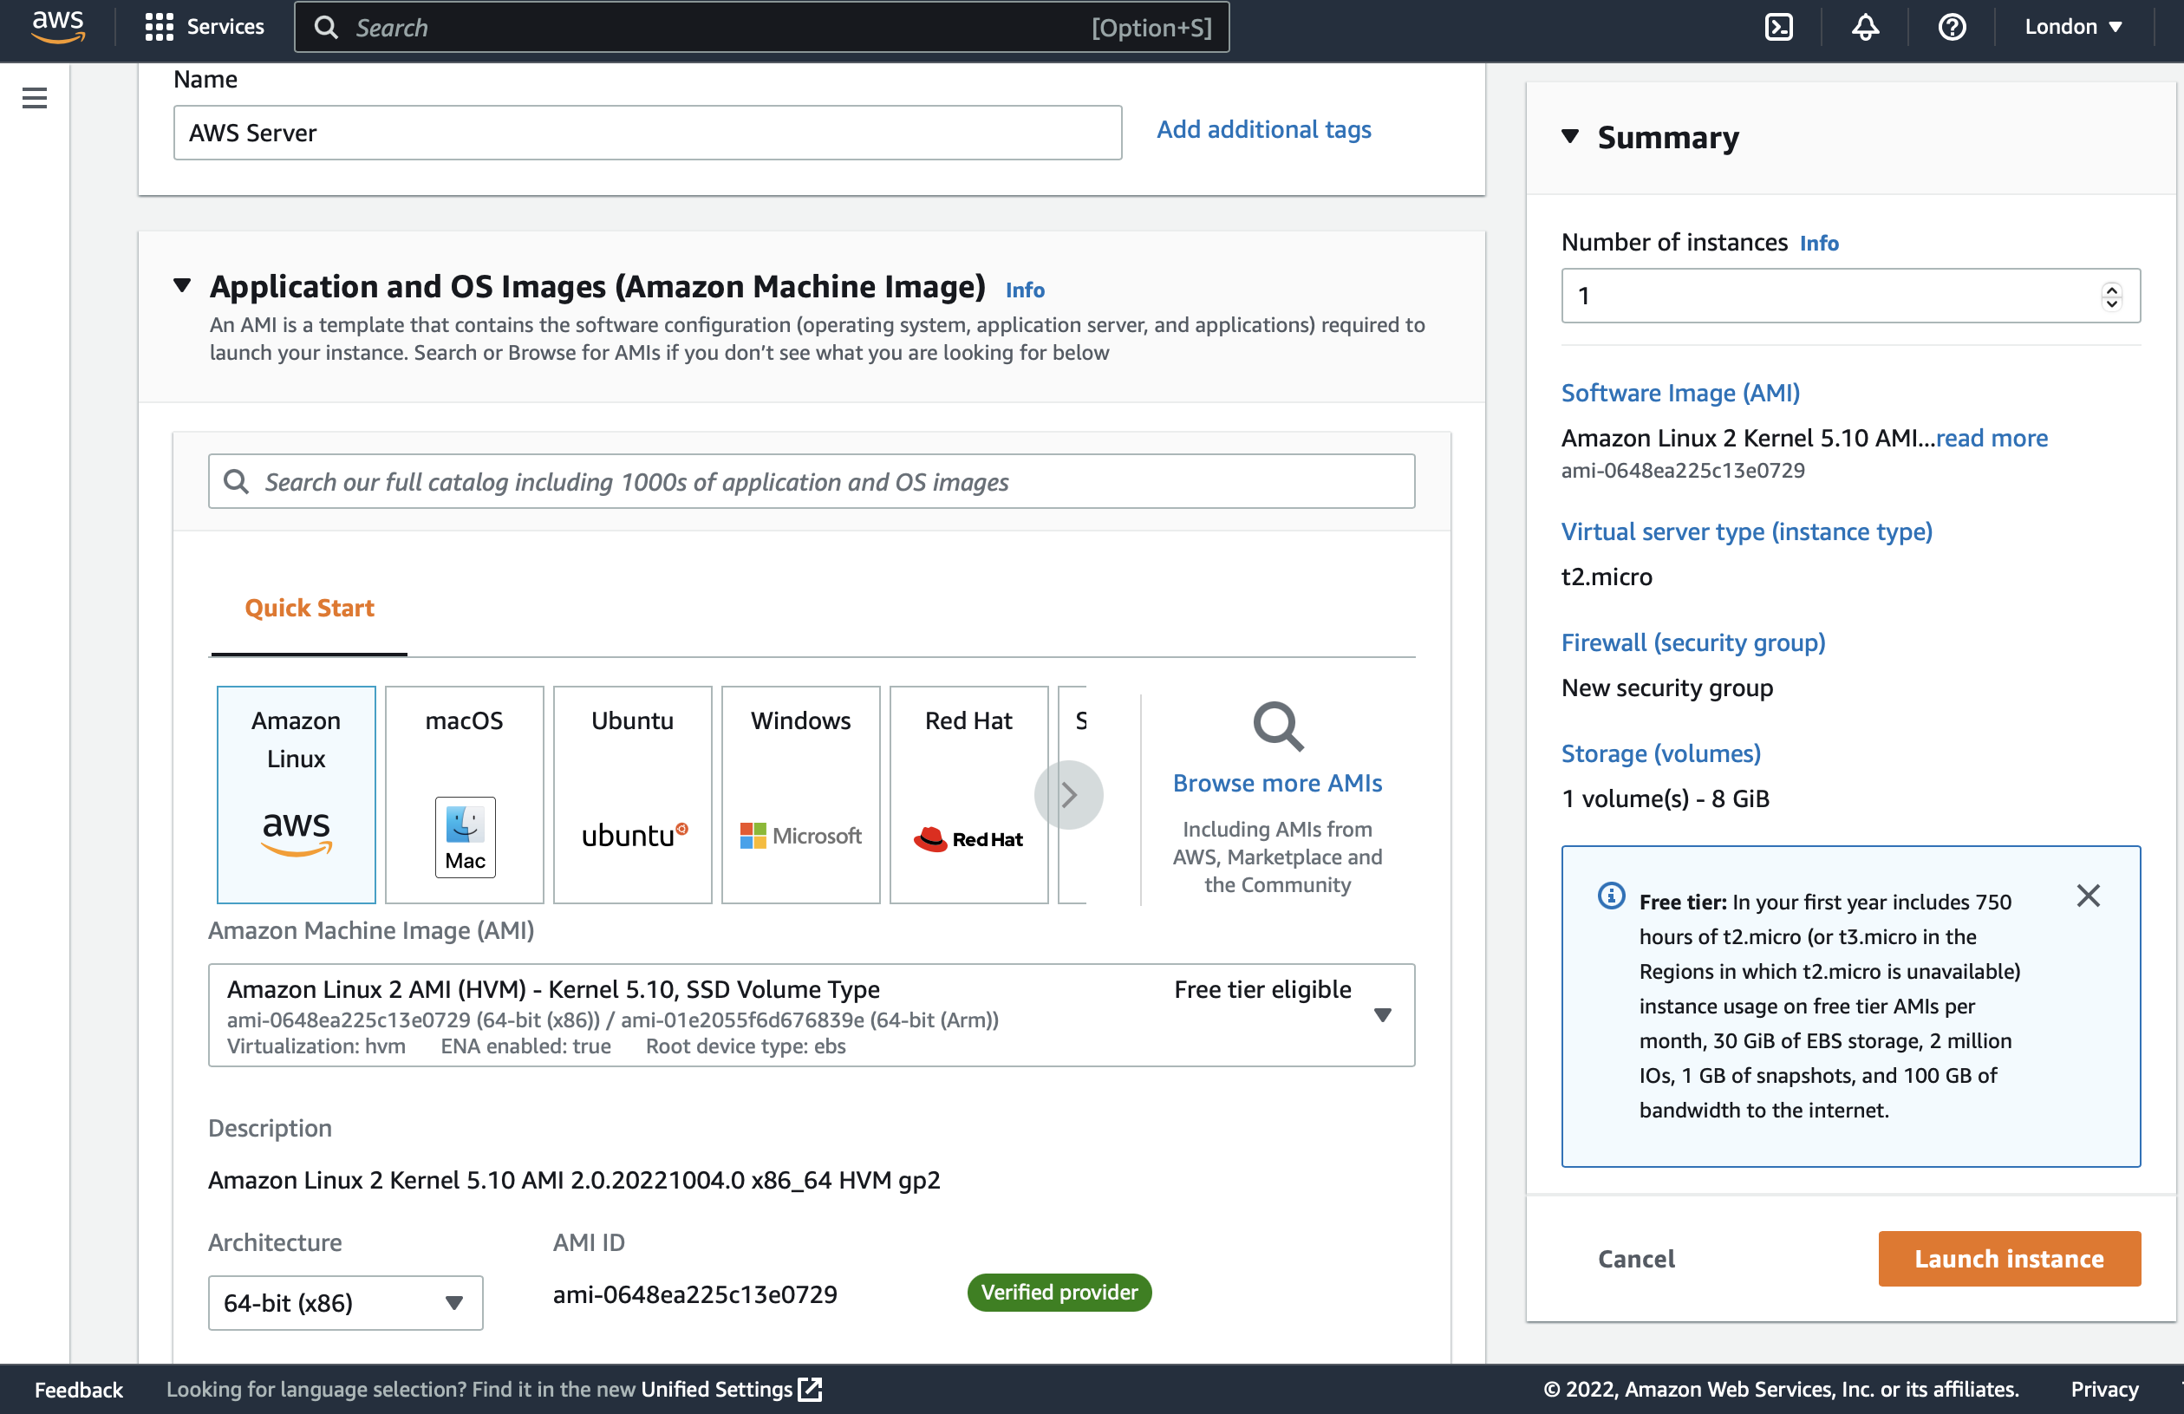

Now create a new key pair which is an .pem file used for connecting our AWS Server instance. Here I have used RSA encryption and .pem extension for connecting the server with SSH.

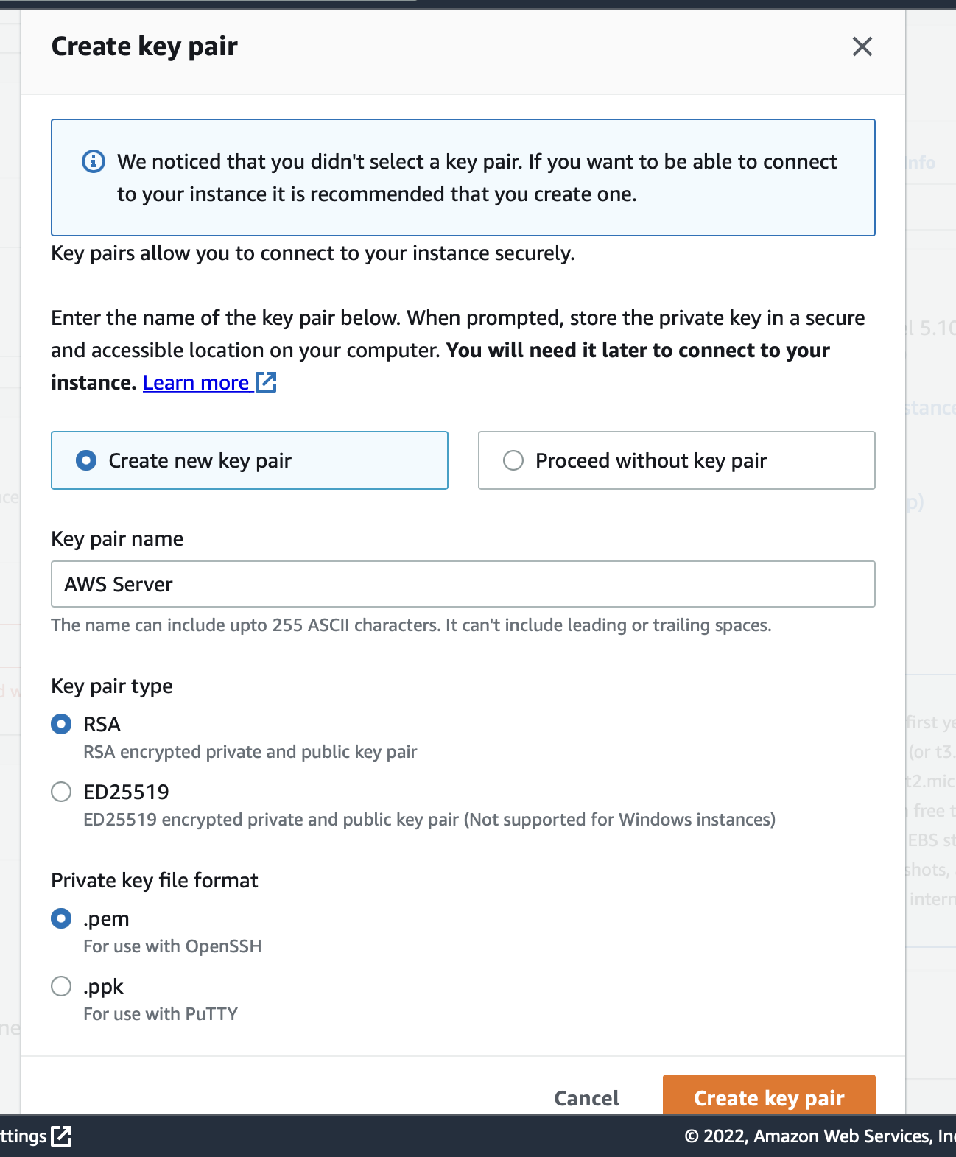

Now after generating the key pair try to connect our AWS Server through Gitbash, GitKraken or Mac Terminal.

For connecting to the AWS Server instance use the following command, you can also find this command by clicking on the AWS Server instance -> connect -> SSH Client

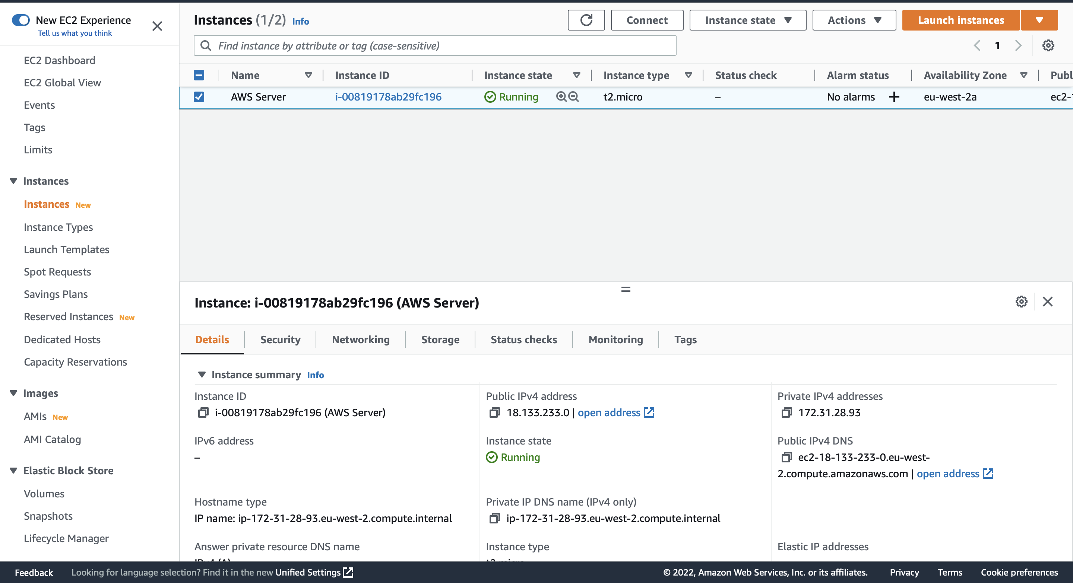

**ssh -i "AWS Server.pem"** [**ec2-user@ec2-18-133-233-0.eu-west-2.compute.amazonaws.com**](mailto:ec2-user@ec2-18-133-233-0.eu-west-2.compute.amazonaws.com)

Make sure while connecting to the server you are at the exact location where .pem file exists, here in my case my .pem file is in the Downloads and make sure that you must change the file permissions of the .pem file before connecting or else it will give, and error called permission denied. You can change the permissions by using the command

**Chmod 400 AWSServer.pem**

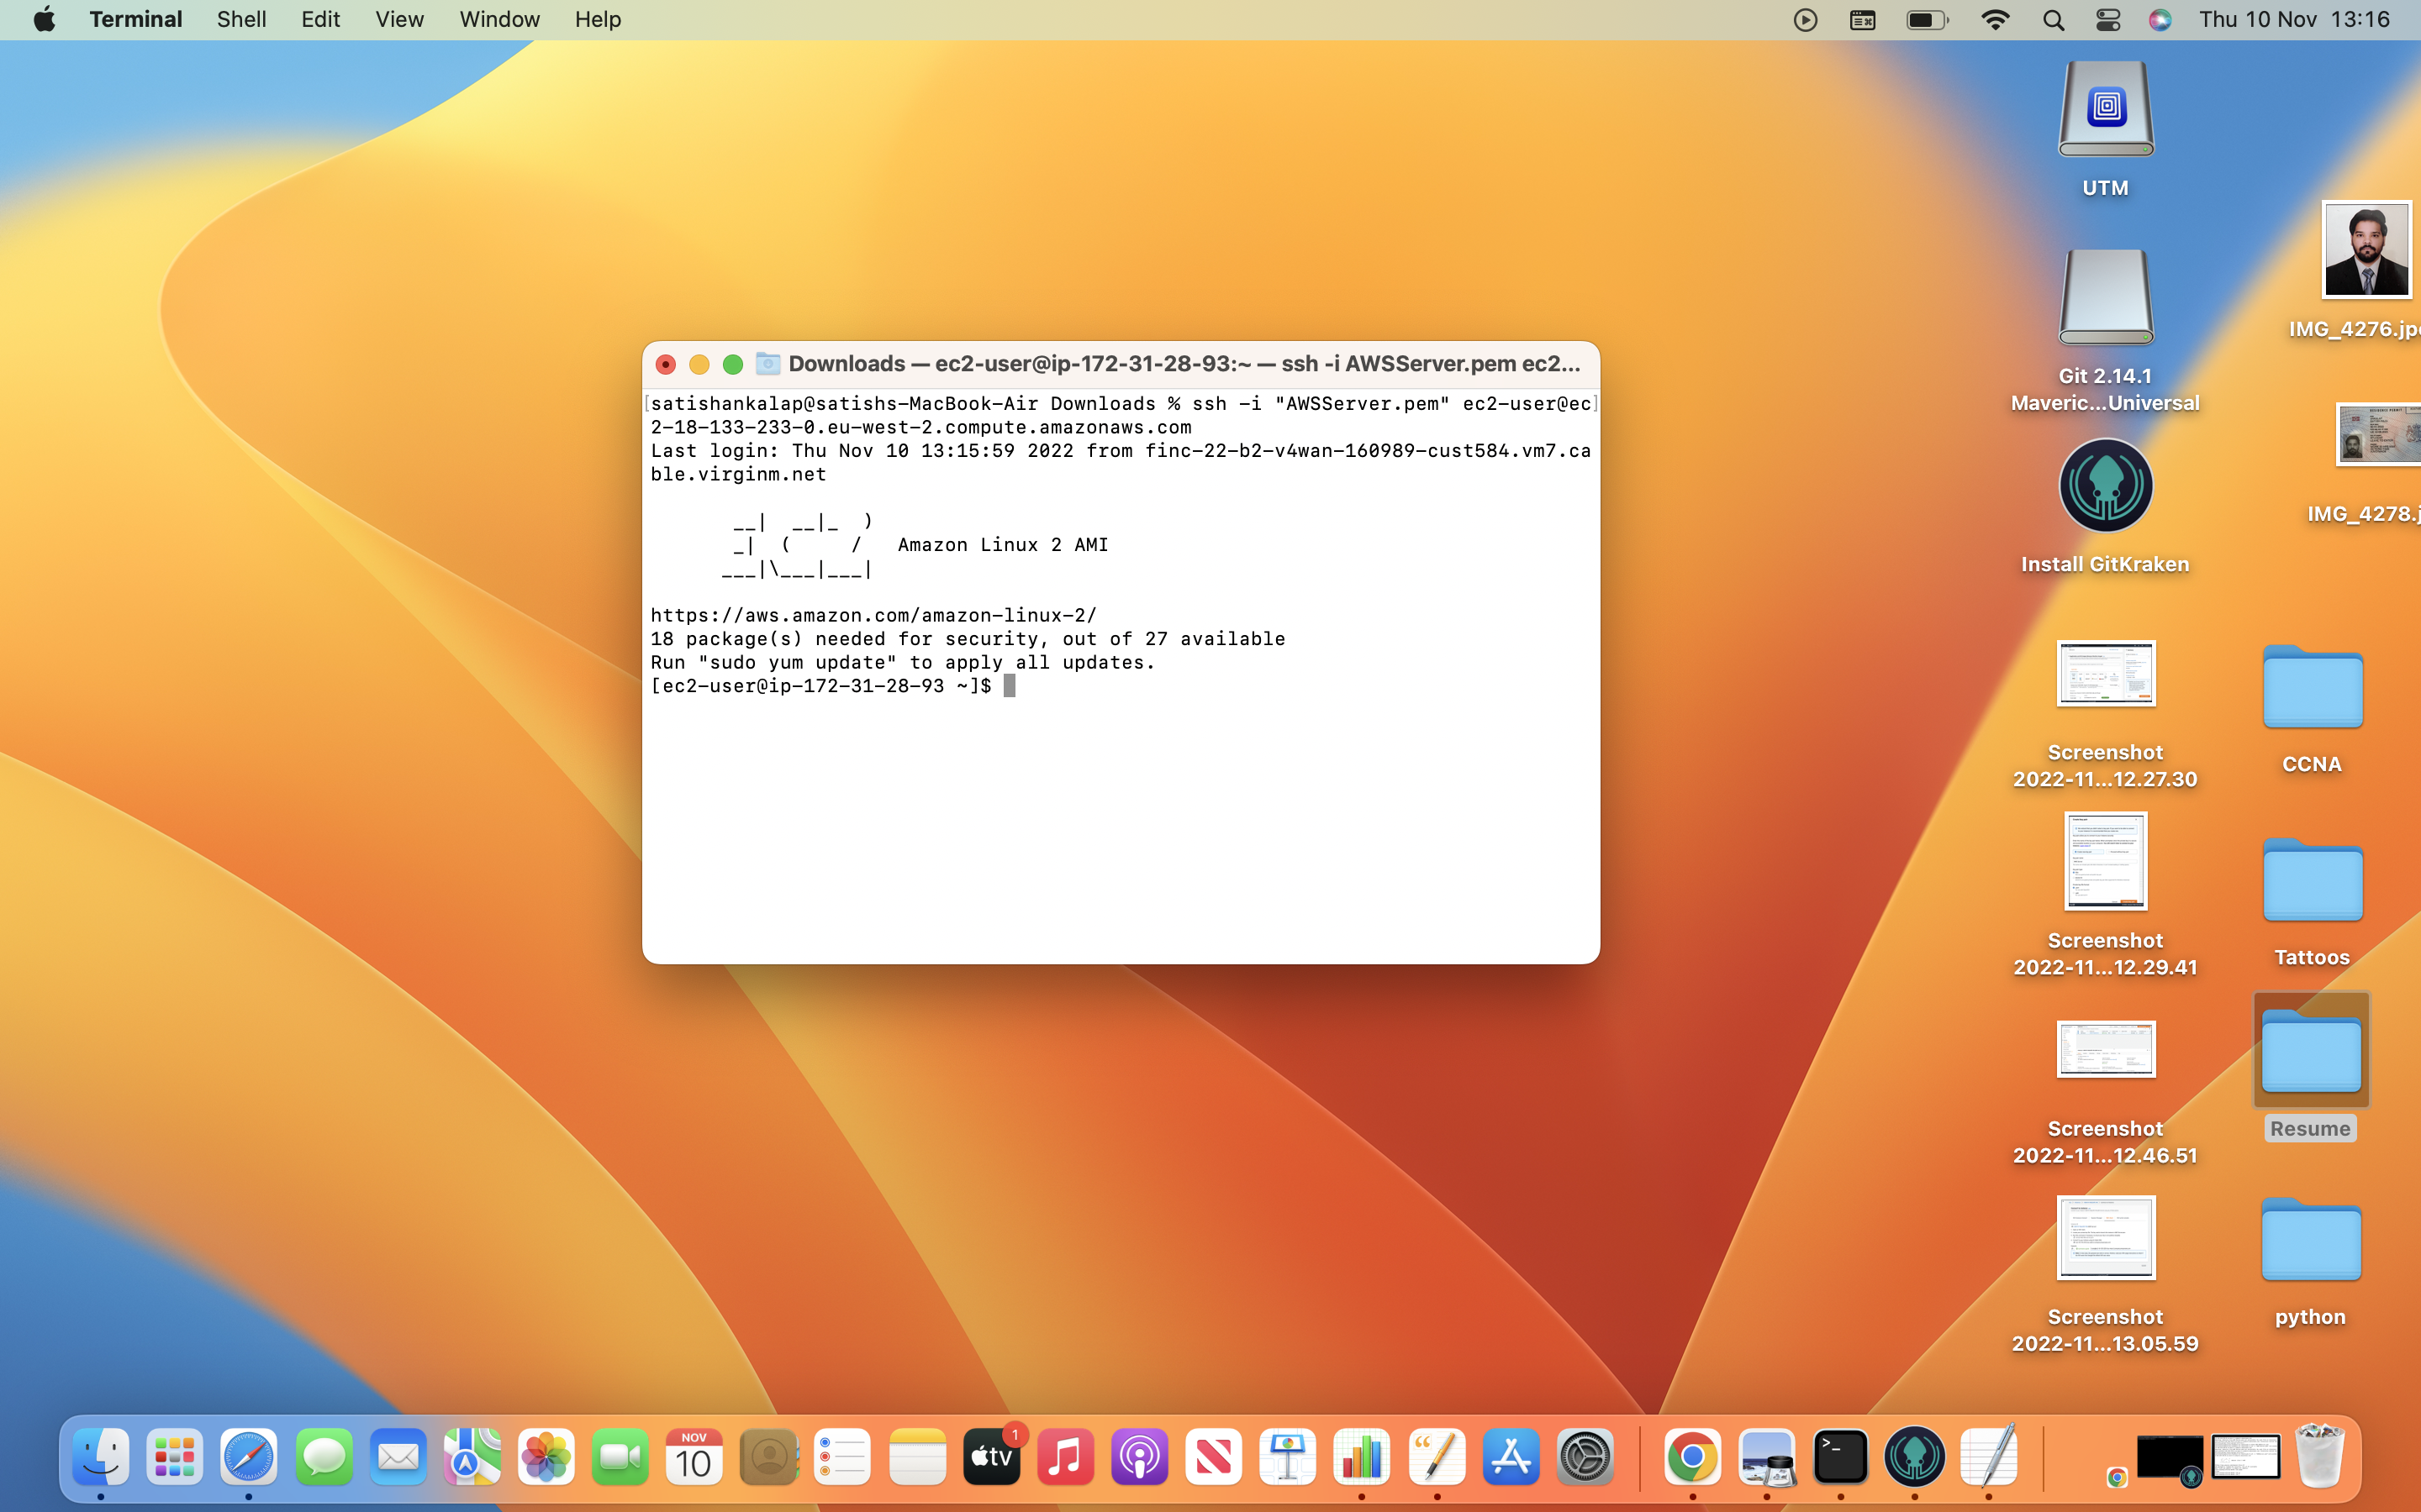

After Connecting to the server now we need to copy the file from our local machine to the server (AWS Server), here I am copying my Resume.docx from my local machine to the server

I will now open another terminal and use the SCP command to copy my docx file to the server. Here is the command to copy the file in this command you must use the public DNS of the server (AWS Server)

Go to Services->Compute->Instances->Instance Summary

**scp -i AWSServer.pem Resume.docx ec2-user@DNS:/home/ec2-user**

In my case here is the public DNS I have used in the below command.

**scp -i AWSServer.pem Resume.docx ec2-user@ec2-18-133-233-0.eu-west-2.compute.amazonaws.com:/home/ec2-user**

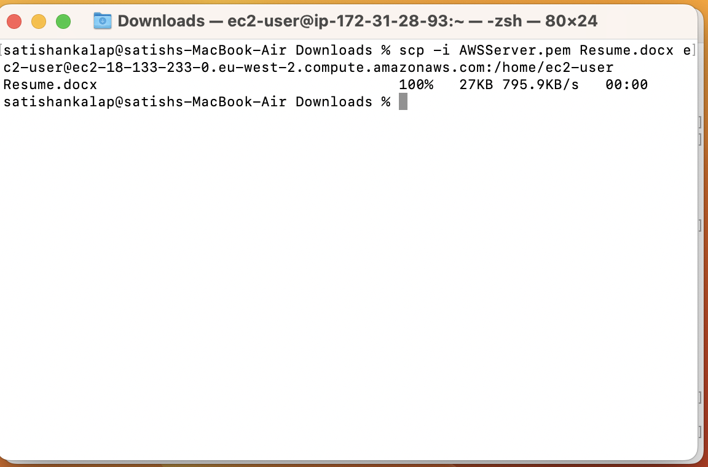

After successfully copying the Resume.docx to the server get back to the other terminal which is connected to the server. And check whether the copied file exists or not for that just use the command **ls**

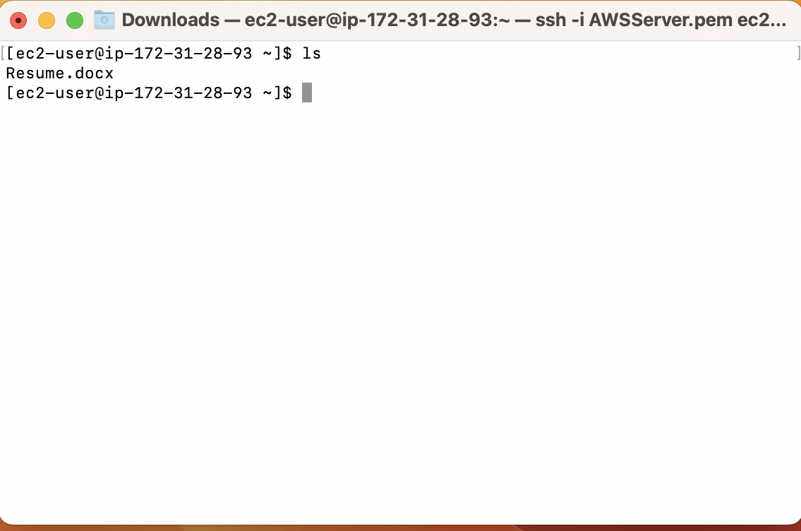

I can see that Resume.docx is successfully copied onto the server. Now we need to create an S3 Bucket using CLI and copy this Resume.docx into the S3 Bucket. Now you need to configure AWS by providing access and secret keys as well as your region. This access and secret keys can be found in the .csv file which you have downloaded at the time of user creation. The command used to configure AWS is

**aws configure**

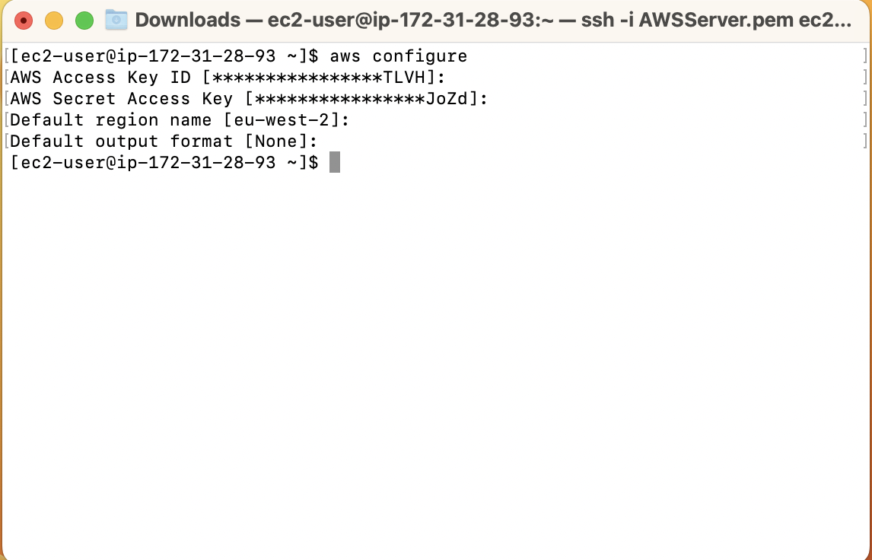

You can find the region in the top left corner of the instances. Just mention the region ex: eu-west-2

If you want to check your access and secret keys just use the command mentioned below

**cat ~/.aws/credentials**

Now enter the command to check the S3 list, it will give you an error because for the AWSUser we haven't attached any permissions.

**aws s3 ls**

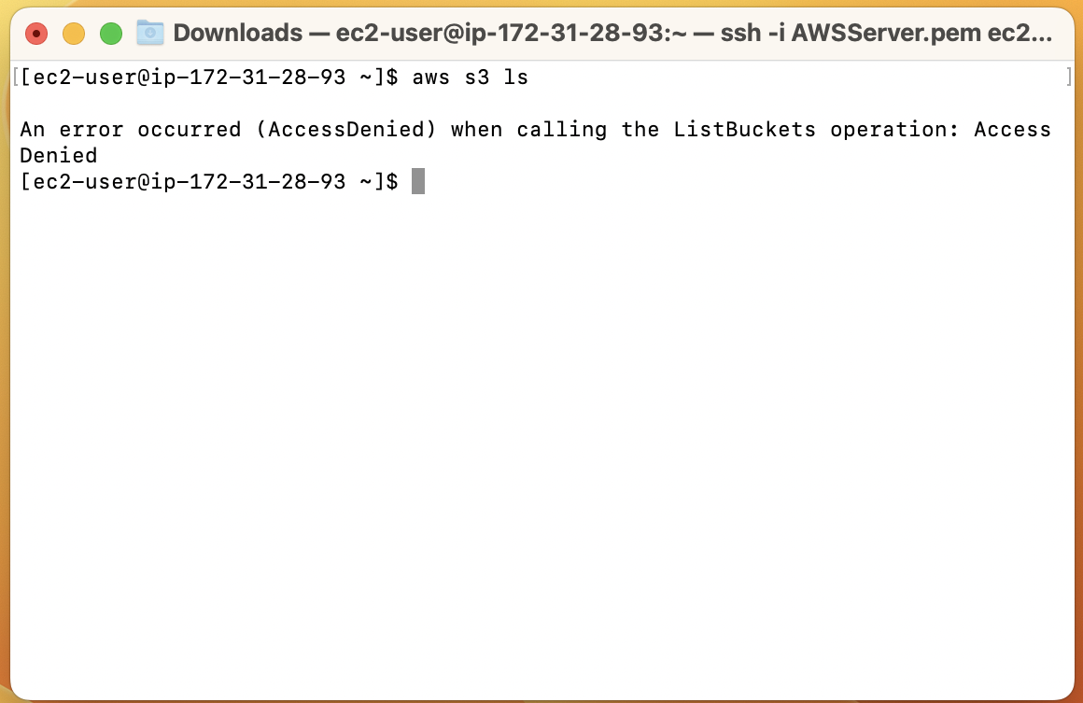

Now to avoid this error, we need to attach the S3 Full Access permissions to the AWSUser.

Goto Services->Security, Identity & Compliance-> IAM-> Users-> Click on AWSUser -> Add Permissions -> Attach existing policies directly -> Amazon S3 full access -> Review -> Add Permission

After adding the permissions to the AWSUser as we are not using Roles here, you can now go to the terminal and us the same command to list the S3 bucket

**aws s3 ls**

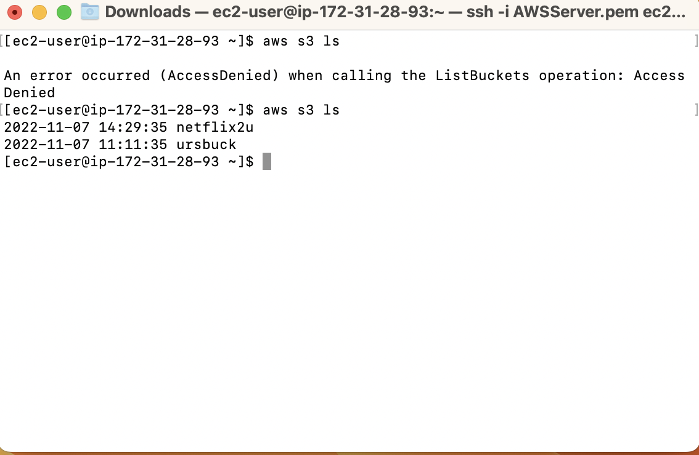

In my case I have already got some S3 buckets so it shows the list in your case it may be empty.

Now create a S3 Bucket and copy the Resume.docx into the bucket that's it we are done.

For creating the S3 Bucket use the following command, make sure you give globally unique name to the bucket.

**aws s3 mb s3 ://bucketname**

Ex

**aws s3 mb s3://urdocs**

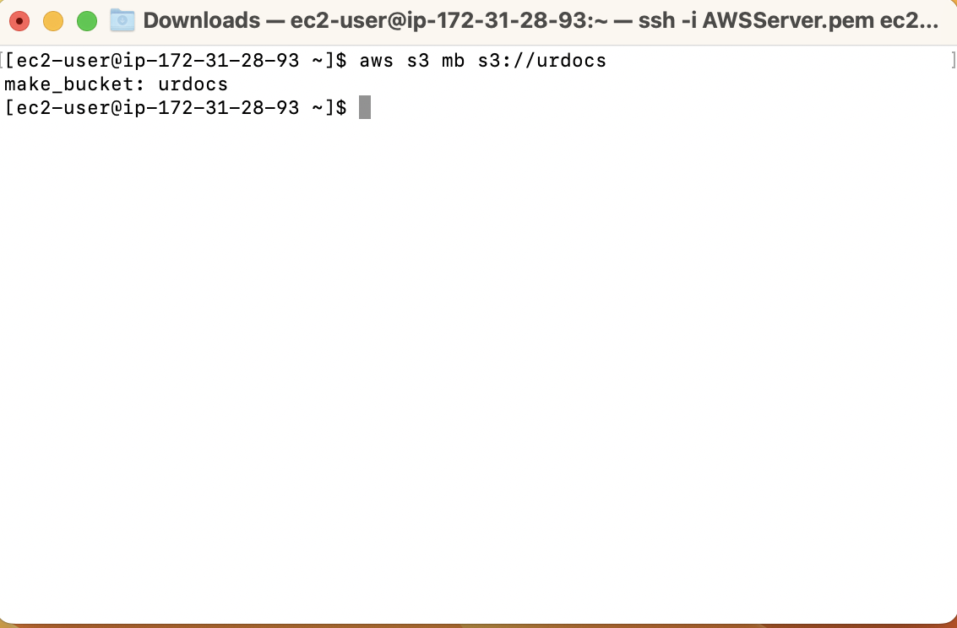

Now copy the Resume.docx to the created S3 Bucket using the command

**aws s3 cp Resume.docx s3://urdocs**

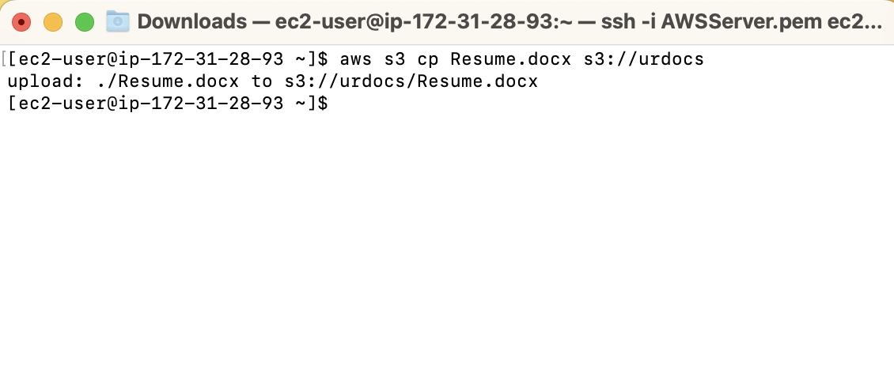

Now you can see the file Resume.docx is uploaded into the S3 Bucket. To confirm you can go to the Services -> Storage -> S3

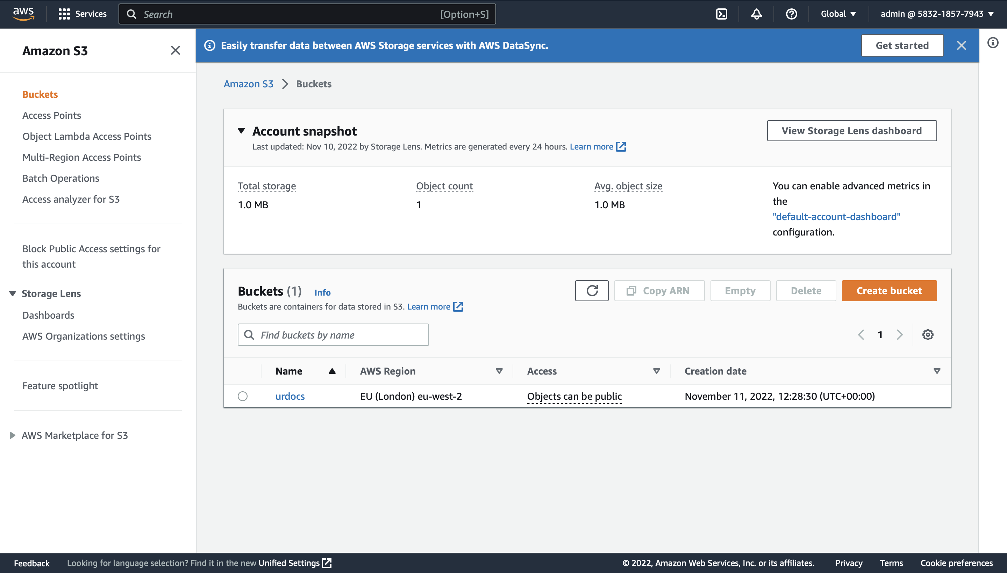

Here you can see the Bucket and if you click on the Bucket urdocs you can see the file Resume.docx

